LAB 8

**MIDHA TAHIR**

**SE – 87**

**Program 1:**

Create a Point Class consisting of two members x and y. Override Tostring() method and inherit Circle class from the Point Class that should include one data member radius and calculate area and circumference of a circle.

namespace lab9_q1

{

public partial class Form1 : Form

{

public Form1()

{

InitializeComponent();

}

public class Point

{

protected int xval, yval;

public Point()

{

}

public Point(int x, int y)

{

xval = x;

yval = y;

}

public void setxval(int x1)

{

xval = x1;

}

public void setyvalue(int y1)

{

yval = y1;

}

public override string ToString()

{

return xval + "\t" + yval;

}

}

public class Circle : Point

{

private double radius;

public Circle()

{

}

public Circle(int x, int y, double r)

{

xval = x;

yval = y;

radius = r;

}

public void setradius(double r1)

{

radius = r1;

}

public virtual double Area()

{

return Math.PI * radius * radius;

}

public override string ToString()

{

return " The center of a circle is " + base.ToString() + " Radius is " + radius;

}

}

private void Form1_Load(object sender, EventArgs e)

{

string output;

Point P = new Point(10, 56);

output = P.ToString();

textBox1.Text = output + Environment.NewLine;

P.setxval(20);

P.setyvalue(34);

textBox1.Text += P.ToString();

Circle C = new Circle(34, 67, 8);

textBox1.Text += Environment.NewLine + C.ToString();

}}}

**OUTPUT:**

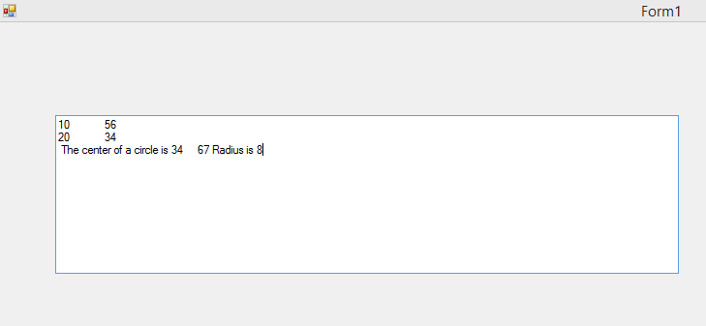

**Program 5**

Create a Calculator class that offers four methods. Add, subtract, multiply and Divide. Consisting of two private members of type double to take input from the user. Create object of a class and start using the calculator class.

**CODING:**

namespace calculate_lab_9

{

public partial class Form1 : Form

{

public Form1()

{

InitializeComponent();

}

public class calculator

{

protected double num1, num2;

public calculator() { }

public calculator(double n, double m)

{

num1 = n;

num2 = m;

}

public void setn(double n)

{

num1 = n;

}

public void setm(double m)

{

num2 = m;

}

public double add(double n,double m)

{

double addition;

addition = n + m;

return addition;

}

public double subtract(double n, double m)

{

double subtract;

subtract = n - m;

return subtract;

}

public double multiply(double n, double m)

{

double product;

product = n * m;

return product;

}

public double divide(double n, double m)

{

double division;

division = n / m;

return division;

}

}

private void Form1_Load(object sender, EventArgs e)

{

}

double number1, number2;

string opertr;

private void button1_Click(object sender, EventArgs e)

{

calculator c1 = new calculator();

number1 = Double.Parse(Microsoft.VisualBasic.Interaction.InputBox("Enter First Number"));

textBox1.Text += Environment.NewLine + number1 + Environment.NewLine;

number2 = Double.Parse(Microsoft.VisualBasic.Interaction.InputBox("Enter Second Number"));

textBox1.Text += number2 + Environment.NewLine;

opertr = Microsoft.VisualBasic.Interaction.InputBox("Enter operator: +,-,*,/");

if (opertr == "+")

{

double mysum = c1.add(number1, number2);

textBox1.Text += Environment.NewLine +"The sum is : " + mysum;

}

else if (opertr == "-")

{

double mysub = c1.subtract(number1, number2);

textBox1.Text += Environment.NewLine + "The result of subtraction is : " + mysub;

}

else if (opertr == "*")

{

double myproduct = c1.multiply(number1, number2);

textBox1.Text += Environment.NewLine + "The product is : " + myproduct;

}

else if (opertr == "/")

{

if (number2 == 0)

{

textBox1.Text += Environment.NewLine + "Math Error";

}

else

{

double mydivide = c1.divide(number1, number2);

textBox1.Text += Environment.NewLine + "The result of division is : " + mydivide;

}

}

else

textBox1.Text += Environment.NewLine + "Invalid Selection";

}

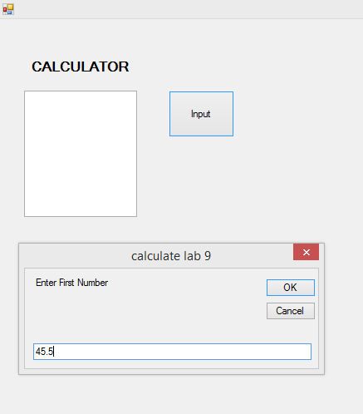**FORM OUTPUT:**

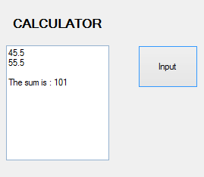 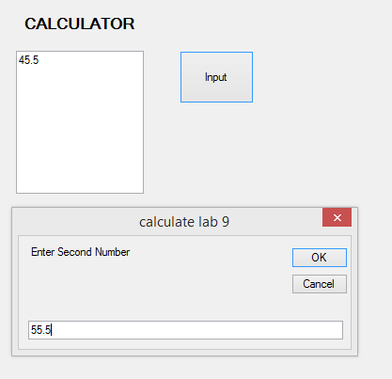

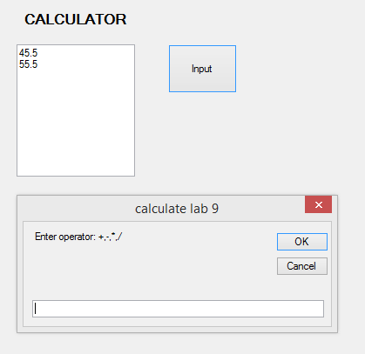

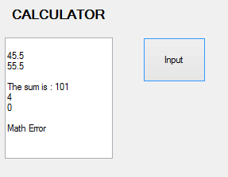

**Program 4**

**(A)** Create a class, which should contain following instance variables, methods, properties and constructor

1. Instance variables: Speed, Numberofdoors, power, Gear, and Color
2. Initialize a Constant variable: Enginenumber
3. Provide Properties to manipulate every private variable
4. Initialize three constructor with different number of parameter/argument
5. Provide method Accelerate ( ), which increase the speed of the car by:
   1. gradually (1 by 1)
   2. value given by user
6. Provide another method IsMoving ( ), which return true if the speed of the care is greater then Zero (0) and return false if the speed of the car is 0

**(B)** Create a Main program, which perform following task:

1. Initialize three objects of class car. Each object initialized by different parameter, in such a way that all the constructor that you create in car class could be use
2. Display values of all the instance variables of car class
3. Assign new values to all the instance variables of car class
4. Display new values of all the instance variables of car class
5. Call Accelerate ( ) method without given any value as an argument
6. Display value of instance variable Speed
7. Call Accelerate ( ) method with some integer value as an argument
8. Display value of instance variable Speed
9. Assign value Zero (0) to the instance variable Speed of car class

CODING:

namespace lab_9_q4a

{

class Program

{

static void Main(string[] args)

{

bool ans;

car c1 = new car(34);

car c2 = new car();

car c3 = new car(20, 4, 32, 4, "blue");

c3.toDisplay();

c3.sets(23);

c3.gets();

c3.setn(2);

c3.getp();

c3.setp(3);

c3.getp();

c3.setg(2);

c3.getg();

c3.sets(23);

c3.getc("blue");

c3.toDisplay();

c1.accelerate();

ans = c1.isMoving();

Console.WriteLine(ans);

c1.accelerate(3);

ans = c1.isMoving();

Console.WriteLine(ans);

c1.sets(0);

ans = c1.isMoving();

Console.WriteLine(ans);

c2.accelerate();

ans = c2.isMoving();

Console.WriteLine(ans);

Console.ReadLine();

}

}

public class car

{

private int speed, Numberofdoors, power, gear;

private string color;

private const int Enginenumber = 123;

public car() { }

public car(int s, int n, int p, int g, string c)

{

speed = s;

Numberofdoors = n;

power = p;

gear = g;

color = c;

}

public car(int s)

{

speed = s;

}

public void sets(int s) { speed = s; }

public void setn(int n) { Numberofdoors = n; }

public void setp(int p) { power = p; }

public void setg(int g) { gear = g; }

public void setc(string c) { color = c; }

// public void seten(int en) { Enginenumber = en; }

public int gets() { return speed; }

public int getn() { return Numberofdoors; }

public int getp() { return power; }

public int getg() { return gear; }

public string getc() { return color; }

public void toDisplay()

{

Console.WriteLine("The speed of the car is " + speed);

Console.WriteLine("The doors in the car are " + Numberofdoors);

Console.WriteLine("The power of the car is " + power);

Console.WriteLine("The gear of the car is " + gear);

Console.WriteLine("The color of the car is " + color);

Console.WriteLine("The Engine Number of the car is " + Enginenumber);

}

public void accelerate()

{

speed = 0;

speed = speed + 1;

Console.WriteLine("The speed is :" + speed);

}

public void accelerate(int s)

{

speed = 0;

speed = speed + s;

Console.WriteLine("The speed is :" + speed);

}

public bool isMoving()

{

if (speed == 0) { return false; }

else if (speed > 0) { return true; }

else return false;

}

}

}

**OUPUT:**

